
Hostay
SOFTWARE REQUIREMENT SPECIFICATION

By
Team 17
Sejal Arora (2041159)
Sauriya Nalli (2041134)
Rudrangshu Tripathy (2041129)

Under the guidance of
Dr. Prabu M.

Department of Computer Science
CHRIST (Deemed to be University)
January 2022

TABLE OF CONTENTS
1. Introduction
1.1. Project Description
1.2. Existing System
1.3. Objectives
1.4. Purpose, Scope, and Applicability
1.4.1 Purpose
1.4.2 Scope
1.4.3 Applicability
1.5. Overview of the Project

2. System Analysis and Requirements
2.1. Problem Definition
2.2. Requirement Specification
2.2.1. Functional Requirements
2.2.2. Technical Requirements
2.3. System Requirements
2.3.1. Software Requirements
2.3.2. Hardware Requirements
2.3.3. Network Requirements
2.4. Conceptual Models
2.4.1. Data Flow Diagram
2.4.2. ER Diagram
2.5. Planning and Scheduling
2.5.1. Gantt Chart
2.5.2. PERT Chart
2.6. Proposed Tools
3. Module Descriptions
3.1. Searching for Hostels/ PGs
3.1.1. Location
3.1.2. Budget
3.1.3. Facilities
3.1.4. Services
3.1.5. Categories of rooms
3.1.6. Type of room
3.1.7. Safety
3.2. Food
3.3. Health and Covid Related Information
3.4. Sustainability
3.5. Places nearby
3.6. Transportation
3.7. Enrolling Hostels

4. Proposed Database
5. Proposed Process Logic of Modules
6. Reports Generated

1. INTRODUCTION
1.1 PROJECT DESCRIPTION
“Home away from Home”- We are looking forward to this motto by creating an online hostel management system that helps students to book an accommodation of their choice and feel comfortable just like their home. As we know there are multiple hostels available everywhere however, there is no such medium to find them from a distant place or to search them online. We eliminate this issue and help all the students find the best hostel according to their comforts and needs.
Our project is solely based on providing a home away from home to all the students who are in search of hostels, PGs, and even rented apartments as well. It not just provides the list of all the hostels available but also helps students and parents shortlist all the hostels according to their wish list. Since our project has two end-users, it also enables Hostel, PG owners to display their hostel details and get bookings.
The students may then chat with the hostel owners and get the deal finalized. After the deal is done, both parties may provide feedback/ratings to each other. The bidding system ensures two things. Firstly, the students can save time by finding a perfect hostel online that fits their budget. Secondly, healthy competition allows the students to choose the best suitable hostel for themselves.

1.2 EXISTING SYSTEMS
The idea of Hostay is quite similar to how the websites or apps for booking the best suitable hotel or holiday destination work, but the idea behind Hostay is to find the best suitable Hostel, PG, or Flat and not a hotel. In other words, Hostay could be considered as a website for searching for a hostel in any city near any college, office, or place in India. Here are some of the existing systems Hostay has derived inspiration from.
1.2.1. MakeMyTrip.com or Goibibo.com:
These are the most popular platforms in India to book a hotel, resort, etc for your holiday destination. These platforms are the inspiration behind creating Hostay to search and book the best suitable hostel for students in their desired place in India.
1.2.2. Airbnb.com:
This is another very popular site that allows users to search and rent a place to stay for a selected period of time. It doesn't look for a hotel but rather home or private rooms which you can book and stay. It also provides various options for amenities to chose from. This website inspires us to add all the minute details to our website so that students can find a home away from their homes.

Although we weren't able to find out an exactly similar or existing system that implements the features that are bundled by HoStay, therefore our website is more of a combination of different features from different platforms and amalgamating them into a unique combination that has never been built.

1.3 OBJECTIVES
Every student once in his/her life experiences hostel life. Most of the students shift to a new city or a new place to experience exposure in life. Talking about our college experience itself most of us shifted to Bangalore and we all faced a lot of issues in searching for the best hostel that suits the needs of both ours and our parents. The main objective of this website is to reduce this problem of looking for hostels from place to place, spending hours, and still not being able to find that one perfect hostel/ PG of our choice. But here on our website, the student can search whatever hostel they want while sitting back in their houses. This saves so much time, energy and also students can connect to PG/Hostel owners so easily. Even parents are stress-free as they know now that their child is in the best hostel they could look for. This website is also a help to all the hostel/PG owners as they can advertise their hostels on our website and get students to stay with them.

1.4. PURPOSE, SCOPE, AND APPLICABILITY

1.4.1. Purpose
As we know there are multiple hostels available everywhere however, there is no such medium to find them from a distant place or to search them online. The main purpose of this website is to reduce this problem of looking for hostels from place to place, spending hours in a new city to look for a hostel, and still not being able to find that one perfect hostel/ PG of your choice. Here on our website, the student can search whatever hostel they want while sitting back in their houses. This saves so much time, energy, stress, and also students can connect to PG/Hostel owners so easily. Another purpose is that here the application will be a help to all the hostel/PG owners as they can advertise their hostels on our website and convince students to choose their hostel.

1.4.2. Scope
The scope of this website is inevitable as it is directly linked with a real-life problem that almost every student faces in his/her life. The project will help students save so much time and energy and book a desired hostel/PG easily while sitting in one place. The project is feasible as it can be used for a
long time without any problems. The Internet has become a part of everyone's life and it should also benefit students in looking for a place to
live just like their home. Our website not only benefits the students but also the hostel owners to advertise their hostels, put up the best services their hostel has to offer, and convince the students to stay at their place.

1.4.3. Applicability
The project is applicable to all students and hostel/PG owners out there. Hostel owners can register themselves on the website and start advertising for the hostel. On the other hand, students as well as their parents can list their requirements and can select the best possible hostel that suits all of their needs and wishes. The concept is applicable to all the cities in India and it will help students focus on minute requirements and find a home away from their home.

1.5. OVERVIEW OF THE PROJECT
This report has given a brief description of our project, Hostay, an accommodation searching website for all the students, office going people looking for a place to move in This is a completely new platform and it reduces the student's effort to search multiple websites and call up different phone numbers, which would normally be the process without Hostay. Our website saves so much time, energy and also students can connect to PG/Hostel owners so easily.
This idea is similar to hotel booking websites like MakemyTrip.com, AirBNB.com, etc. Just the difference is instead of hotels or resorts; we help you find a home away from your home. The main objective of Hostay is that the student can search whatever hostel, with whatever requirements they want while sitting back in their houses. The project is applicable for both occupants searching for accommodation and hostel owners looking for occupants.

2. SYSTEM ANALYSIS AND REQUIREMENTS
2.1. PROBLEM DEFINITION
The scenario of choosing a Hostel is to go over to individual sites and compare them manually. This is where Hostay comes into play we not only eliminate this issue but also provide a hands free and smooth journey of a customer to choose their desired hostel. Our website also comes with several features that make the users’ job to filter out their requirement much easily and efficiently.

2.2. REQUIREMENT SPECIFICATION
2.2.1. FUNCTIONAL REQUIREMENTS
2.2.1.1. Post Product Option
- Customers can see the photo of the hostels that they want to choose.
- Customers can provide filters or specifications of the hostels to be rented.
- Hostels can share the posts with other people.

2.2.1.2. Search Facility
- Customers can easily search for their desired hostel of stay.
- Customers can also search their preferred hostels using various filters like location, food, security etc.

2.2.1.3. AI Recommendation System
- Occupants can also get their desired option of stay using filters.
- Similar results will be generated and recommended to them using the filters they selected.

2.2.1.4. Chatting Facility

- Occupants and Hostel owners can chat with each other using the chatting option available on the website.
- Occupants can explain the modifications required in their stay
- It can be used for finalizing the hostels and explaining the requirements.

2.2.1.5. Report Generation
- The admin can see reports related to the sales done on the website.
- Different filters can be used to see reports on the basis of time or categories.
- Recommendation system can be improved by using the reports data.

2.2.1.6. Graphical Dashboard
- Occupants and Hostel owners are provided with a graphical dashboard where they can see their past bookings on the website with the help of graphs.
- They can modify their personal information.
- They can edit or add their profile pictures using their dashboard.

2.2.2 TECHNICAL REQUIREMENTS
2.2.2.1. Data Privacy

- The data provided by the users will be kept private and will not be shared with everyone.
- The chats done between hostel owners and students for bookings will be kept confidential and will be read by anyone else.
- The personal data will be kept private and very important data will be encoded using a hashing function.

2.2.2.2. Performance

- The performance of the project depends on the internet connectivity of the user as the data will be saved on a Server.
- It will be a web application therefore requires a browser as a client which can communicate with the server or host.
- It also depends on the version of the Operating system and hardware in the device.

2.2.2.3. Data Security
- All the information provided by the users will be kept in a most secure manner.
- The site will not be having any loopholes or bugs through which hackers
- can get access to the database and steal data.
- Confidential information will never be kept on the user's side in the form
- of cookies to maintain security
.

2.2.2.4. Data Transfer
- Data should always be transferred using a secure socket layer.
- The protocol used for transmission should be secure and should follow all the security guidelines.

2.2.2.5. Data Storage
- The data will be stored in a database in the server.
- Users will be able to see data according to their permissions.
- The password will never be echoed and saved in the database after encryption.
- The database can only be accessed directly by the authenticated users such as admin who are a part of the company.

2.2.2.6. Reliability and Maintainability
- The system always maintains a log file to recover from any errors.
- Backup of the database is taken at regular intervals to ensure that the data can be recovered later on.
- The website can be maintained by the development team.
- They can add new modules and improve existing modules and security of the website at regular intervals for maintaining effectiveness and efficiency.

2.3 SYSTEM REQUIREMENTS
2.3.1 Hardware Requirements

COMPONENT | MINIMUM | RECOMMENDED
Processor | 1.9 gigahertz (GHz) x86- or x64-bit  dual-core processor | 3.3 gigahertz (GHz) or faster 64-bit  dual-core processor
Memory | 2-GB RAM | 4-GB RAM or more
Storage | 128 GB | 512 GB
Display | Super VGA with a resolution of 1024 x 768 | Super VGA with a resolution of 1024 x 768 or more

2.3.2 Software Requirements

COMPONENT | MINIMUM | REQUIREMENT
Operating Systems | Windows 7 or Ubuntu 14.04 or OS X El Capitan 10.11 | Windows 10 or Ubuntu 18.04 or Catalina 10.15.7
Web Browser | Google Chrome 69.0 or Mozilla Firefox 71.0 | Google Chrome 69.0 or Mozilla Firefox 71.0
HTML | HTML5 | HTML5.2
CSS | CSS3 | CSS3
Javascript | ECMAscript 2016 | ECMAscript2018
PHP | PHP6 | PHP8
MySql | Server5.6 | Server8.0
Python | PYTHON2 | PYTHON3.6
Server | LAMP 0.010 or WAMP 2.5 | LAMP 0.0.12 or WAMP 3.0.3

2.3.3 Network Requirements

COMPONENT MINIMUM RECOMMENDED
Bandwidth | More than 50 KBps | 400 KBps
Latency | Latency Under 150ms | 75ms

2.4 CONCEPTUAL MODELS

2.4.1 Data flow Model
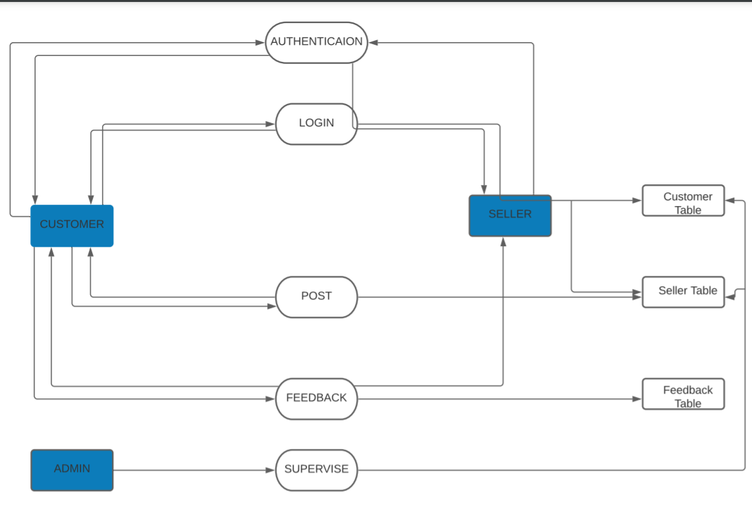

2.4.2 ER Diagram
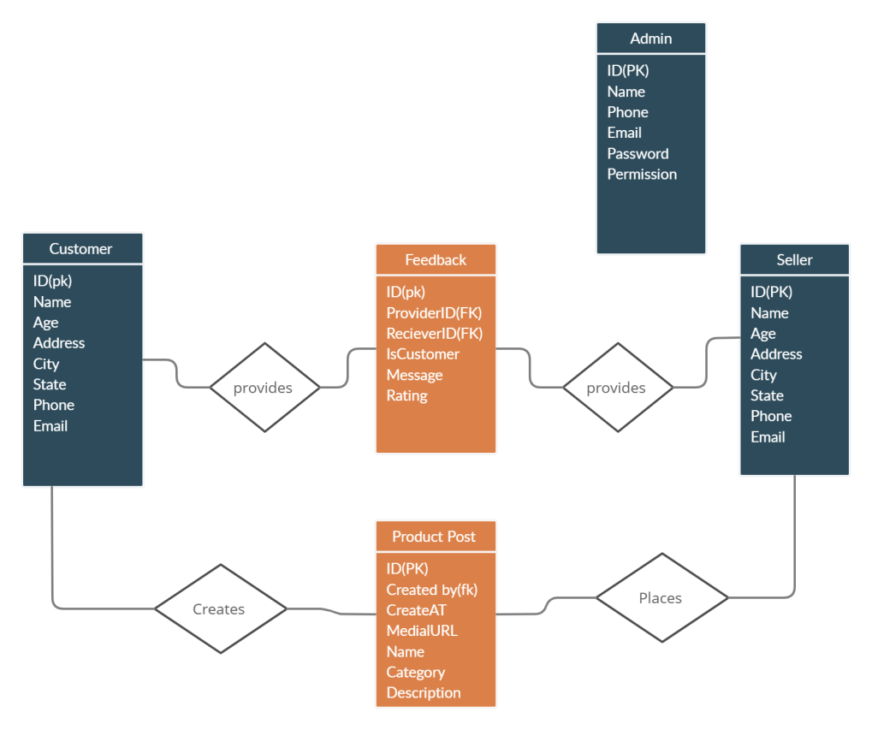

2.5 PLANNING AND SCHEDULING
2.5.1 Gantt Chart
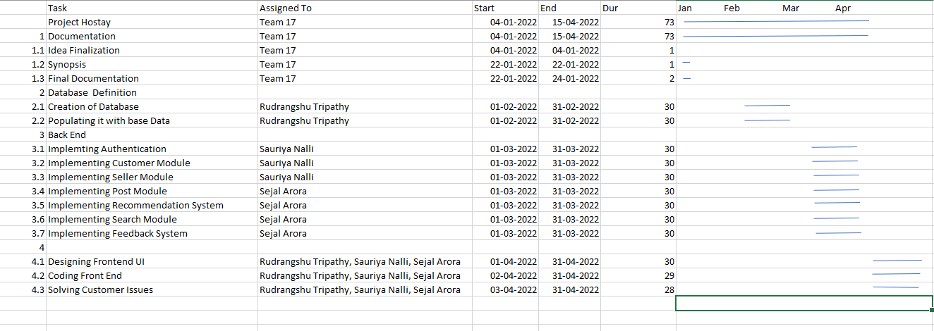

2.5.2 PERT Chart

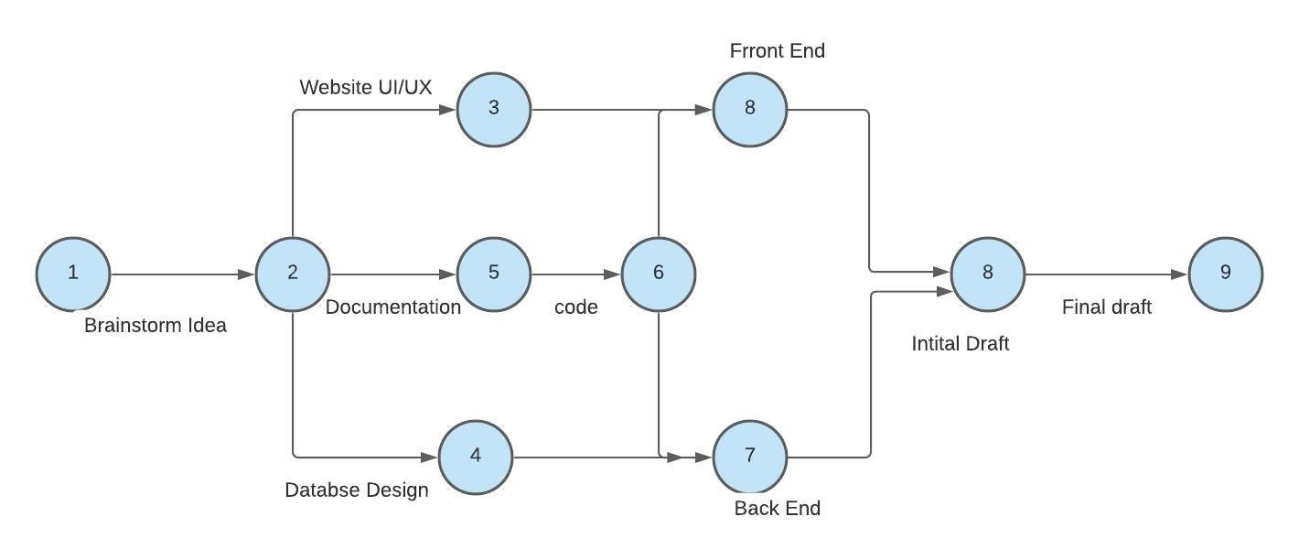

2.6. PROPOSED TOOLS AND PLATFORMS

2.6.1. Windows 11
Microsoft Windows 11 is a personal computer operating system developed and released by Microsoft. All the files containing code and database will be created in the Windows 11 operating system.
2.6.2. Google Chrome
Google Chrome is a cross platform web browser developed and maintained by Google. All the HTML and PHP files will be opening using Google Chrome for viewing their functionality and working.
2.6.3. HTML
HTML stands for Hypertext Mark-up Language which is the standard mark-up language for documents designed to be displayed in a web browser. The basic web pages design will be implemented using HTML.
2.6.4. CSS
CSS or Cascading Style Sheets is a style sheet language used for describing the presentation of a document written in a mark-up language such as HTML. It will be used for adding more design and improving the look and feel of the website.
2.6.5. Javascript
JavaScript, often abbreviated as JS, is a programming language that conforms to the ECMAScript specification. It is high-level, often just-in-time compiled, and multi-paradigm. It will be used to make the website responsive and dynamic.
2.6.6. PHP
PHP is a general-purpose scripting language especially suited for web development. It will be used to write the codes for the server side and connect to the database.
2.6.7. Python
Python is an interpreter, high-level and general-purpose programming language. It will be used for creating a recommendation system. The machine will be stored on the server for continuous working.
2.6.8. MySQL
MySQL is an open-source relational database management system. The data will be stored in a database inside MySQL while following maximum normal forms.
2.6.9. Server
WAMP or LAMP will be used as temporary servers for checking the website before deploying it on the server. WampServer refers to a solution stack for the Microsoft Windows operating system, consisting of the Apache web server, Open SSL for SSL support, MySQL database and PHP programming language.
2.6.10. Adobe Illustrator
Adobe Illustrator is a vector graphics editor and design program developed and marketed by Adobe Inc. It is used to design the website for checking its look and feel. The design then can be implemented through coding.

3. MODULE DESCRIPTIONS

3.1 SEARCHING FOR HOSTELS/ PGS:
This is one of the major and most important modules of our domain. This includes the first set of filtration of choice of hostel, PG, etc. that the user is looking for.
This module shortlists all the available hostels, PGs as per the user’s interest. It has further sub-modules such as-
3.1.1 Location: Basically means the area in which the accommodation is situated. This helps the user to filter the area; city and location where he wants his/her hostel.
3.1.2 Budget: All occupants have a different range of budget in their mind. Facilitating to that we have a wide range of budgets for each and every person looking for a hostel.
3.1.3 Facilities: It is an amenity, or a piece of equipment provided for a particular purpose. This includes anything like a gym, games room, entertainment room and swimming pool which the students can filter out according to their needs and choose a hostel with respect to that.
3.1.4 Services: This includes services that the hostel/PG will be providing which are necessary for the survival of the student such as Wi-Fi connectivity, laundry services, furniture, room cleaning etc.
3.1.5 Categories of rooms: In hostels the rooms are categorized and priced according to number of occupants, number of beds in a room, storage space, attached bathroom, decor, specific furnishings or features. Categories can include whether the room is a PG, a hostel, a rented flat, etc.
3.1.6 Type of room: This includes whether it is a single sharing, double sharing, triple sharing room, ventilation, AC, non AC, etc.
3.1.7 Safety: Safety of the student is one of the most important things a parent looks at while searching for a hostel. A safe accommodation includes stuff like a full-time security guard, CCTV cameras, etc.

3.2 FOOD:
Each individual student has his/her own specific need, taste, and preference in food. This module will ensure that students and their parents are both satisfied with their diet. Students can choose a respective food package and select the time and days when they need the service. They can pick and choose the cuisine, the category (veg or non-veg) , the place from where they need the food and the time when they need the service.

3.3 HEALTH AND COVID RELATED INFORMATION:
In an ongoing pandemic health is one of the most important criterions for a student in his search for a hostel. A healthy hostel periodically sanitizes the rooms, has regular clean-ups, has got hygienic food, etc. We made sure to add this module as we are amongst a pandemic and parents are really scared to send away their children to hostels. This module will help parents to ensure that the hostel they choose follows specific covid protocols and is really safe for their child.

3.4 SUSTAINABILITY:
This is one of our unique elements as it will provide knowledge about how sustainable the particular hostel is to the environment such as reduction in wastage of food, eco-friendliness, etc. This is one such idea that makes our website unique and different from all. We care for the environment and we want to encourage hostels to be more sustainable as we will suggest students the hostels that are most sustainable.

3.5 PLACES NEARBY:
Accessibility to essentials can make a huge difference in a student’s life. This Includes things like laundry services, grocery stores, electronic shops, stationery shops, clothing stores, etc. This module will help the user know how far these places are from their desired hostel. This module also includes how far are places like supermarkets, salons, grocery stores, stationery shops, airports, etc. from that hostel.

3.6 TRANSPORTATION:
This is important as students need to travel to and fro from the hostel/PG. Transportation facility is very essential especially when you move to a new city and you are totally unaware of the routes and places around. This module helps students to get transportation facilities from various companies. They can choose a time, a place and a destination where they want to go and book transportation services for a period of time. It includes transportation facilities like bus, car, auto, bike etc.

3.7 ENROLLING HOSTELS:
This is for the Hostels owners, PGs to display their details and get bookings through our website. This website really helps all the hostel/PG owners as they can advertise their hostels on our website and get students to stay with them. They have to fill out a form and our admin will decide whether the hostel/PG meets our requirement. Once the hostel/PG is enrolled on our website we will help them get students, occupants to stay. They can also chat with them and convince why their hostel/PG is best suited.

4. PROPOSED DATABASE
DATABASE NAME- Hostel Management System
TABLES- Hostel details, Services, Occupant Details, Occupant Guardian Details, Warden Details, Amenities, Essentials Nearby, Food, Transport, Feedback.
Table 4.1.Proposed Database
Tablename | Column 1 | Column 2 |  | Column 3 | Column 4 | Column 5 | Column 6 | Column 7 | Column 8 |  | Column 9
Hostel details | Hostel Id | Type (PG, Hostel, Flat) |  | Name | Address | City | Contact | Email
Services | Wi-Fi | Laundry |  | Meals | Hot water | Power backup | House keeping | Entertainment
Occupant details | Occupant Id | Requirement |  | Name | Address | City | Contact | Email | Age |  | Occupation
Occupant guardian details | Occupant Id | Relation  (Parent,  Guardian) |  | Name | Address | Email | Contact
Warden details | Hostel Id | Warden Id |  | Name | Address | E-mail | Contact
Amenities | Washroom type |  | Balcony | Bed | Fan/AC | Cupboards | Ventilation | Study table | Dustbins
Essentials nearby | Hostel name | Hostel id |  | Grocery | Pharmacy | Stationary | Supermarket | Airport | Laundry Service
Food | Service Name | Contact |  | Type | Price | Timings | Hostel Id | Packages | Cuisine
Transport | Company Name | Contact |  | Type | Price | Timings | Hostel Id
Feedback | Feedback Id | Satisfactory rating |  | Message | User id

5. PROPOSED PROCESS LOGIC OF MODULES
Hostay, an online management system is a platform where students who require accommodation in any city in India will be able to do so in just a few clicks. This is a completely new platform and it reduces the student's effort to search multiple websites and call up different phone numbers, which would normally be the process without Hostay.
The student just has to log in to our website and first select the kind of accommodation and subsequently add the required filter like food, location, services etc. When the results pop up he gets all the features each hostel has like the shops nearby, laundry service around it, etc. The student also has the option of discovering the different kinds of transportation facilities and also can add on a tiffin service if he/she wants. One of the unique feature of our website is it tells you how sustainable or eco-friendly the hostel/PG is. It will also give the details of what covid protocols the hostel is taking.
The website also has another end where small hostel/PG owners can upload their information and advertise their hostels and get students, occupants to stay there.

6. REPORTS GENERATED
6.1. The number of students who require a hostel.
6.2. The number students of who could find a place to stay through our website.
6.3. The number of hostels available on our website.
6.4. Report related to number of Hostel/PG bookings made via our website.

----------------------------------------------------------------------------------------------------

